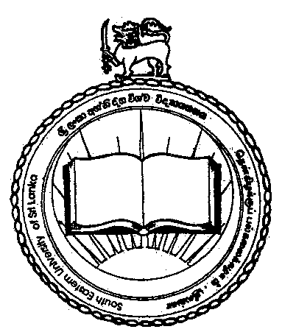

11th GENERAL CONVOCATION - 2017
South Eastern University of Sri Lanka

11th Annual General Convocation of South Eastern University of Sri Lanka will be held on 19th February, 2017 at Bandaranaike Memorial International Conference Hall (BMICH), Colombo. The form of supplication for the conferment of Degrees at the Convocation has already been sent to all graduands who will be conferred degrees at the above convocation.

Duly completed supplication form along with the copy of the Paying-in-Voucher should be sent under Registered Cover to reach the following Address on or before November 21, 2016.

Senior Assistant Registrar
Academic & Students Affairs
South Eastern University of Sri Lanka
University Park
Oluvil # 32360

Please note that supplication forms received after the stipulated date will not be considered for Conferment of Degrees at the Convocation.

The name list of graduands who will be conferred degrees on the above convocation has been uploaded in the university website.

For further details, graduands are requested to contact the Senior Assistant Registrar/Academic and Student Affairs over the Phone / Fax – 067 2255463.

MI. Nawfer
Acting Registrar

